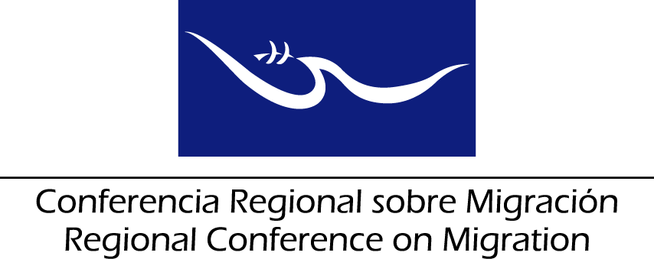

Meeting of the Liaison Officer Network for Consular Protection

Report from the Meeting of the Liaison Officer Network for Consular Protection

San Salvador, El Salvador

21 June 2017

The Liaison Officer Network for Consular Protection held its ordinary meeting on 21 June 2017 in San Salvador, El Salvador prior to the meeting of the Regional Consultation Group on Migration (RCGM), with participation of representatives from the following countries: Canada, Costa Rica, the Dominican Republic, El Salvador, Guatemala, Honduras, Mexico and Panama.

The Network submits its report to the RCGM for consideration, contained in the following items:

- To thank the delegations of Costa Rica, the Dominican Republic, El Salvador, Guatemala, Honduras, Mexico and Panama for their reports on best practices and advances relating to consular protection.

- To thank the delegation of El Salvador for sharing the experience of the initiative to establish the Consular Districts/Customer Service Windows, and to invite the Member Countries whom may consider it convenient, to replicate this experience.

- To thank the delegations of Mexico and Guatemala for their presentation on the results from the online workshop on dialogue and consultation about best practices concerning systems/platforms to record consular actions and cases of consular protection provided to their nationals abroad. To urge the interested countries to get a better understanding of how these systems work, and to this end, to approach the consulates of Mexico in the United States and to the Ministry of Foreign Affairs of Guatemala to obtain first-hand information on the subject.

- To thank RNCOM for their presentation on the initiative of the Central America and Mexico Migration Alliance (CAMMINA) for the advances on the development of the directory of civil society organizations that will cooperate with consulates in providing protection and assistance to migrants. Recognize the relevance of the mapping and request Member Countries to send to the TS the name of the contact person in each country to disseminate this information, and to identify if delegations are interested in including any additional information before mid-July this year.

- To thank RNCOM for the presentation on the contributions made by its member organizations in providing protection and assistance to migrants, in coordination with consulates, and to take note of their proposals to promote synergies for the protection of migrants.

- To thank ICRC for the proposal on humanitarian actions regarding missing migrants to benefit their families, and the identification of deceased persons. To take note of the proposal by the ICRC to continue including this theme in the agendas of the RCM and to evaluate the creation of an Ad-Hoc group to advance in the agreements that are reached in this regard.

- To thank Costa Rica for its presentation on the Report of the Regional Training Workshop "The Protection of Nationals Abroad Affected by Crises". To thank IOM for its willingness to support the follow-up of the actions emanated from this workshop and to take note of the virtual course on this subject that is available on its learning platform.

To take note of Mexico's proposal to seek to strengthen the specific capacities of consular officials in a crisis context; as well as the actions taken by Guatemala in terms of coordination with the competent institutions for the reduction and prevention of disasters to strengthen the actions of their consular representations in crisis situations.

- To thank the delegations of Mexico and El Salvador for their presentation on the TRICAMEX Initiative and to recognize its importance for the joint work on consular protection, the exchange of experiences and the management of cases in the region.

To take note of the interest of Member Countries to continue working on the creation of joint consulates as well as in actions for preventive protection.

TRICAMEX has generated positive synergies in health, education, counselling and preventive protection that benefit the Guatemalan, Salvadoran, Honduran and Mexican populations in the United States of America.

- To suggest the RCGM the approval of the following activities in the framework of the RCM:

- With regard to the Workshop on the consular protection of migrant workers, reaffirm the interest of countries to carry it out with the support of ILO and IOM, which will circulate a concept note through the Technical Secretariat to confirm the needs of the countries in this topic and possible contributions to co-finance the face-to-face workshop. Take note of the offer by the ILO and IOM to develop an online training module on this subject.

- To take note of Honduras' request to conduct a workshop for consular officials, including national emergency prevention systems, to continue the training process initiated by the MICIC initiative.

