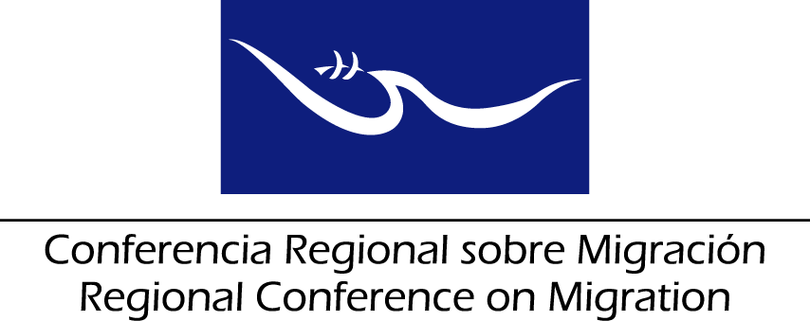
MEETING OF THE LIAISON OFFICER NETWORK FOR THE PROTECTION OF MIGRANT BOYS, GIRLS AND ADOLESCENTS
Report of the Liaison Officer Network for the Protection of Migrant Boys, Girls and Adolescents
San Salvador, El Salvador
20 June 2017
The Liaison Officer Network for the Protection of Migrant Boys, Girls and Adolescents met on 20 June 2017 in San Salvador, El Salvador with participation of representatives from Canada, Costa Rica, the Dominican Republic, El Salvador, Guatemala, Honduras, Mexico, Panama and the United States and submits its report to the Regional Consultation Group on Migration (RCGM), contained in the following items:
- To thank the delegations of Canada, Costa Rica, the Dominican Republic, El Salvador, Guatemala, Honduras, Mexico, Panama and the United States for the presentation of their reports on new efforts and best practices relating to assistance and protection for migrant girls, boys and adolescents.

- To thank the President pro tempore for the presentation of the Work Plan of this Network. In addition, to thank the Member Countries for their active participation in the development of the Plan; and to thank the RCM Technical Secretariat (TS) for systematizing and incorporating the input of the RCM Member Countries into the Plan.

- Regarding the contents of the Plan, Mexico requests to harmonize the Plan with the developments of the World Summit for Children. To this end, Mexico will draft a proposal of paragraph which will be added to the Plan; this paragraph will be shared with the TS in advance to the meeting of the RCGM for its incorporation into the Plan.

- To suggest to the RCGM the approval in principle of the Strategic Plan of the Liaison Officers Network for the Protection of Migrant Girls, Boys and Adolescents of the RCM for 2017-2022. In regards to the “Responsible” column included in the Plan, it will be completed afterwards through an internal consultation process to be carried out by each Member Country. Each Member Country will communicate to the TS its proposal of responsible entity for each action of the Plan, in order to be able to complete it. If needed, a virtual meeting of the RCM will be organized to fill in this column.

- To suggest that the RCGM urge the RCM Member Countries to disseminate the plan within their respective governments and request support from relevant institutions in the implementation of the Strategic Plan.

- To take note of the recommendations of the Regional Network for Civil Organizations on Migration (RNCOM) concerning joint efforts of civil society and RCM relating to assistance and protection of migrant girls, boys, and adolescents.

- To thank the International Committee of the Red Cross (ICRC) for the presentation of the document jointly prepared with UNHCR and UNICEF, on alternatives for detention, such as, alternative care in the context of irregular migration, especially that of migrant and refugee girls, boys and adolescents. To take note of the challenges and best practices highlighted by the ICRC.

- In order to continue with the implementation of the Work Plan, to request the support of the ICRC for the drafting of a document on best practices with regards to alternatives for the detention of migrant and refugee girls, boys and adolescents.

- To suggest, once the Strategic Plan of the Liaison Officer Network for the Protection of Migrant Girls, Boys and Adolescents of the RCM for 2017-2022 has been approved, to implement, as appropriate, the following priority actions with the aim of advancing in the implementation of the Plan:

- To request UNHCR to continue strengthening protection procedures, at the operative level, focused on the best interest of girls, boys and adolescents, especially with regards to refugees with specific profiles of vulnerability. UNHCR highlighted its commitment to support such capacity building processes.

- Carry out a compilation of best practices and a map of specialized actors and services relate to the protection and assistance of migrant girls, boys and adolescents with the support from IOM.

