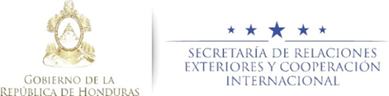
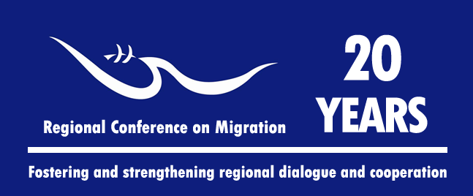

Meeting of the Liaison Officers Network for Consular Protection
Regional Consultation Group on Migration (RCGM)

Centro Social Hondureño Árabe
Room to be determined
San Pedro Sula, Honduras

15 November, 2016

PRELIMINARY AGENDA
08:15 – 09:00 Registration of participants and opening words

09:00 – 09:15 Approval of the agenda
[Leads: PPT]

09:15 – 10:30 Reports by Member Countries on new efforts / best practices related to consular protection in the context of shared responsibility.
[Lead: All delegations (5 minutes per delegation)]

• Note: Please report only on NEW efforts and practices, and respect the established time limit of 5 minutes for each presentation.

10:30 – 10:45 Break

10:45 – 11:00 Presentation of the concept note for a possible workshop to develop general guidelines for the consular protection to migrant workers.
[Leads: Honduras]

- During the meeting of the Network held in Tegucigalpa on June 7, 2016, in point 6 of the Network's report, Honduras offered to present the concept note.

11:00 – 11:20 Presentations of best practices to move towards a regional platform to register cases of consular protection.
[Lead: Honduras and Mexico]

- During the meeting of the Network held in Tegucigalpa on June 7, 2016, the Member Countries agreed to discuss the possibility of creating a space to exchange best practices in order to advance towards a regional platform of registration of cases of consular protection for interested Member Countries, as well as redefining the desired scope of this initiative. The “Memo of Understanding on the Establishment of a Network for Consular Protection and Humanitarian Aid of Central America and the Dominican Republic in the United Mexican States and potentially, in other North American countries” (signed in December, 2011) recognizes the need to generate and share consular protection programs.

11:20 – 11:40 Presentation of a regional communication campaign on migration of children and adolescents [Lead: IOM/RNCOM].

- During the last meeting of this network, held in Tegucigalpa, 7 June 2016, it was agreed that IOM, in coordination with the TS and focal points designated by governments and other stakeholders, would conform a group to carry out this initiative. Interested Member Countries and civil society organizations, through RNCOM, featuring information campaigns on this subject, offered to share them.

11:40 – 12:00 Presentation on MICIC’s menu of tools and activities.
- Proposal of a Consular Crisis Management and MICIC Guidelines
[Leads: IOM]

12:00 – 12:30 Presentation/dialogue between RNCOM and the RCM on how to ensure the effective participation of civil society to strengthen consular protection.
[Leads: RNCOM]
Note: Including the action plan produced from the meeting held from 26 to 28 October in Tegucigalpa, Honduras.

12:30 – 12:50 Proposals of new activities [Lead: All delegations]
- Workshops of the Platform on Disaster Displacement in, related to the presentation of the "Guide to Effective practices for RCM Member Countries for the protection of persons moving across borders in the context of disasters."
[Leads: Costa Rica]
- Workshops on consular crisis management and on MICIC Guidelines
[Lead: United States/IOM]

12:50 – 13:45 Preparation of the report of the network’s meeting for the RCGM. [Leads: PPT]

