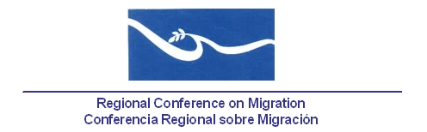

Meeting of the Liaison Officers Network for Consular Protection
Regional Consultation Group on Migration (RCGM)

Hotel Holiday Inn
Cosigüina Room
Managua, Nicaragua

November 24th, 2014

AGENDA
07:30 – 08:30 Registration of participants

08:30 – 08:45 Approval of the agenda and establishment of the Drafting Committee.[Lead: PPT]

08:45 – 09:45 Reports by Member Countries on new efforts and best practices related to consular protection [Lead by: all delegations (5 minutes per delegation)].

- Note: Please refer only to NEW efforts and practices for a maximum of 5 minutes.

09:45 – 10:00 Current status of the Memorandum of Understanding for the Establishment of the Consular Protection and Humanitarian Assistance Network of Central America and the Dominican Republic, in Mexico and possibly in other countries of North America [Lead: all delegations of the countries involved]

- During the last meeting of this Network, held in Managua, Nicaragua, on June 24, 2014, the Government of Honduras expressed its commitment in promoting the approval and entry into force of the document.

10:00 – 10:20 Discussion regarding a possible Regional Cooperation Agreement for the Protection of the Human Rights of Migrants in RCM Member Countries.
[Lead: Costa Rica]

- During the last meeting of this Network, held in Managua, Nicaragua, on June 24th, 2014, Member Countries agreed to submit comments to the TS, so Costa Rica and El Salvador could jointly work on a new proposal.

Reference documents: Costa Rica´s proposal of Agreement

10:20 – 10:35 Dialogue based on the concept note regarding a proposed Workshop to draft general guidelines for the consular protection of migrant workers. [Lead: Nicaragua]

- During the last meeting of this Network, held in Managua, Nicaragua, on June 24th, 201a, it was agreed that Nicaragua and Honduras would work on the concept note.

Reference documents: Presentation regarding the concept note

10:35 – 10:50 Presentation/Dialogue with the RNCOM [Lead: RNCOM]

10:50 – 11:15 Coffee Break

11:15 – 11:30 Update of the Global Consular Forum
[Lead: Mexico and Canada]

11:30 – 11:45 Proposals of new activities [Lead: All delegations]

11:45 – 13:00 Preparation of the report of the meeting for the RCGM [Lead: PPT].

