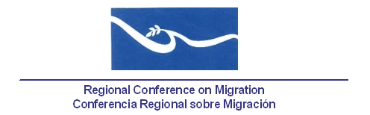
Meeting of the Liaison Officers Network to Combat Migrant Smuggling and Trafficking in Persons

Hotel Holiday Inn
Mombacho & Telica Rooms
Managua, Nicaragua
November 24th, 2014

AGENDA
07:30 – 08:30 Registration of participants

08:30 – 08:45 Approval of the agenda and establishment of the Drafting Committee.[Lead: PPT]

08:45 – 09:45 Report by the countries on new efforts and best practices to combat human trafficking and migrant smuggling since the last meeting of this Liaison Officers Network. (5 minutes per delegation). [Lead: All delegations]

- Note: Please refer only to NEW efforts and practices for a maximum of 5 minutes.

09:45 – 10:00 Progress of RCM Member Countries on the implementation of the Palermo Protocols using the proposal of indicators prepared by the IOM. [Lead: TS]

    - During the most recent meeting of this Network, held in Managua, Nicaragua, 24 June, 2014, Central American countries and Mexico committed to submit their progress to the TS, as well as contact information to request information related to these indicators.

10:00 – 10:30 Progress report regarding the agreements and work of the Regional Coalition against Trafficking in Persons and Migrant Smuggling. [Lead: Coalition´s Representative]

    - During the most recent meeting of this Network, held in Managua, Nicaragua, 24 June, 2014, it was agreed that the Coalition would formally request Member Countries to identify a representative before the Coalition, in order to address the topic of migrant smuggling.

10:30 – 10:45 Update of the Comparative Matrices of the Legislation in Member States of RCM relating to Trafficking in Persons and Migrant Smuggling and upcoming actions. [Lead: TS/IOM].

    - During the most recent meeting of this Network, held in Managua, Nicaragua, 24 June, 2014, Member Countries requested IOM to update the matrices. Also, the TS was requested to ask Member Countries to name a focal point to keep contact with IOM.
    - On September 25, the TS sent by e-mail the updated matrices on Trafficking in Persons for comments and validation, as well as the request for designation of a focal point for contact with IOM.

10:45 – 11:00 Presentation/dialogue with the RNCOM [Lead: RNCOM].

11:00 – 11:20 Coffee Break

11:20 – 11:45 Proposals of new activities [Lead: All delegations]

11:45 – 13:00 Preparation of the report of the network’s meeting for the RCGM. [Lead: PPT]

