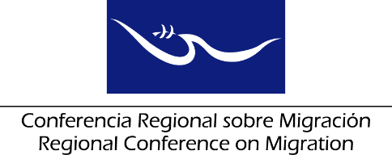 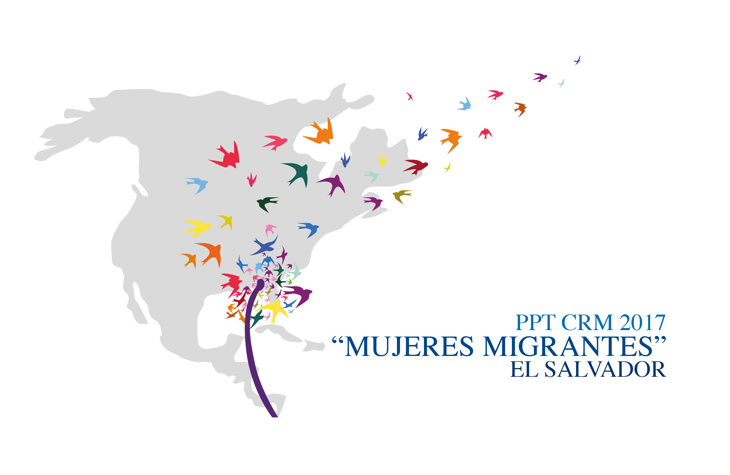

**Meeting of the Liaison Officer Network for Consular Protection**

**Regional Consultation Group on Migration (RCGM)**

**San Salvador, El Salvador**

# June 21, 2017

**PRELIMINARY AGENDA**

08:30 – 08:45 Approval of the agenda

***[Leads: PPT]***

08:45 – 09:45 Reports of the Member Countries on their new efforts/effective practices in consular protection.

***[Lead: All delegations (5 minutes for each delegation)]***

Note: Please only report on NEW efforts and practices, and respect the established time limit of 5 minutes for each presentation.

* Presentation of the Initiative for the creation of “Distritos/Ventanillas Consulares (Consular Services One-Stop Shops)”

***[Leads: El Salvador]***

09:45 – 10:00 Results from the *Virtual Workshop for the dialogue and consultation regarding systems/platforms of consular records and cases of consular protection to nationals abroad*, and follow up on the offerings of Mexico and Guatemala.

***[Lead: México y Guatemala]***

10:00 – 10:15 Report on the progress made for the Directory of the Civil Society Organizations and presentation on the contribution offered by these organizations for the attention and protection of their nationals abroad and the strengthening of the consular network.

***[Leads: RNCOM]***

10:15 – 10:30 Coffee Break

10:30 – 10:45 Following up on the results from the Workshop “Protecting nationals abroad affected by crisis”

***[Leads: OIM]***

10:45 – 11:15 Presentation of the executive summary on the TRICAMEX Initiative.

***[Leads: El Salvador]***

11:15 – 11:45 Proposal of new activities ***[Lead: All Delegations]***

11:45 – 12:30 Preparing a report on the meeting of the Network, to be submitted to the Regional Consultation Group on Migration (RCGM)

***[Leads: PPT]***

12:30 Closure