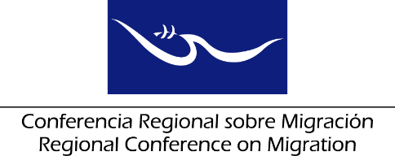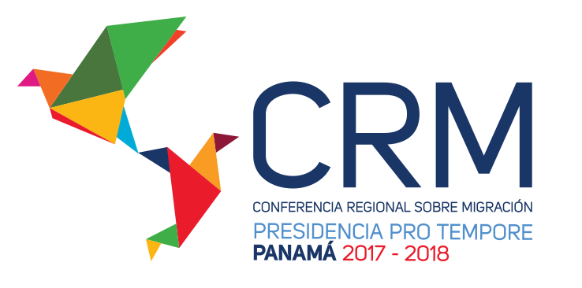

**Meeting of the Liaison Officer Network for Consular Protection**

**Regional Consultation Group on Migration (RCGM)**

Panama City, Panama

# July 19, 2018

**PRELIMINARY AGENDA**

08:30 – 08:35 Approval of the agenda ***[Lead: PPT]***

08:35 – 09:45 Reports of the Member Countries on their new efforts/effective practices in consular protection.

***[Lead: All delegations (5 minutes for each delegation)]***

Note: Please only report on NEW efforts and practices and respect the established time limit of 5 minutes for each presentation.

09:45 – 10:00 Update on a study that includes the best practices, legal frameworks and other inputs that allow the possibility of opening joint consulates among interested RCM Member Countries, focusing on joint protection.

***[Lead: IOM]***

10:00 – 10:15 Coffee Break

10:15 – 10:30 Opening of Consular Windows ***[Lead: El Salvador]***

10:30 – 11:00 Consular assistance around the separation of families ***[Lead: Mexico]***

11:00 – 11:30 Dialogue with RNCOM ***[Lead: PPT-*** ***RNCOM]***

11:30 – 12:00 Proposal of new activities

* Regional Workshop on the Governance of Labor Migration: Towards Integrated and Planned Policies ***[Presented by: Mexico, IOM and ILO]***
* Online course for consular officers ***[Presented by: IOM]***
* Workshop on the development of a regional mechanism for information exchange during the search for missing migrants

(Presentation of the contents of the activity already approved by the deputy ministers) ***[Presented by: ICRC]***

***[Lead: All delegations]***

12:00 – 12:30 Draft of the report on the meeting of the Network, to be submitted to the Regional Consultation Group on Migration (RCGM)

***[Lead: PPT]***

12:30 – 12:45 Reading of the report ***[Lead: PPT]***

12:45 Closure