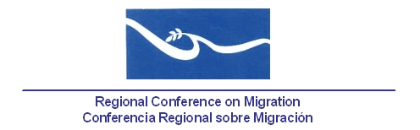
Meeting of the Liaison Officers Network to Combat Migrant Smuggling and Trafficking in Persons

Hotel Holiday Inn
Güegüense Room
Managua, Nicaragua
24 June, 2014

AGENDA
07:30 – 08:30 Registration of participants

08:30 – 08:45 Approval of the agenda and establishment of the Drafting Committee.[Lead: PPT]

08:45 – 09:45 Report by the countries on new efforts and best practices to combat human trafficking and migrant smuggling since the last meeting of this Liaison Officers Network. (5 minutes per delegation). [Lead: All delegations]

- Canada: Update on Irregular Migration Trends

09:45 – 10:00 Progress of RCM Member Countries on the implementation of the Palermo Protocols using the proposal of indicators prepared by the IOM. [Lead: TS]

    - During the most recent meeting of this Network, held in San Jose, Costa Rica, 18November, 2013, the TS agreed to send a reminder to Central American Countries and Mexico to share their progress. No advances have been received.

Reference documents:
- IOM proposal of indicators

10:00 – 10:20 Progress report regarding the agreements and work of the Regional Coalition against Trafficking in Persons and Migrant Smuggling. (Lead:Coalition´s Representative]

10:20 – 10:40 Presentation/dialogue with the RNCOM [Lead: RNCOM].

10:40 – 11:00 Presentation of the publication“Trafficking in Persons for Labor Exploitation in Central America”and Progress of study on existing vulnerabilities in Central America around the illegal removal of organs [Lead: IOM].

Reference documents:
- IOM publication: Trafficking in Persons for Labor Exploitation in Central America (Spanish version only)

11:00 – 11:20 Coffee Break

11:20 – 11:45 Proposals of new activities [Lead: All delegations]

- Update of the comparative matrices on legislation against trafficking in persons and human smuggling and next steps.[Lead: PPT].

11:45 – 13:00 Preparation of the report of the network’s meeting for the RCGM. [Lead: PPT]

