

CONCEPT PAPER
2nd Global Consultation on Migrant Health:
Resetting the Agenda
Jointly Organized by IOM, WHO and the Government of the Democratic Socialist Republic of Sri Lanka

Hotel Cinnamon Grand | Colombo, Sri Lanka
25-27 October 2016

- BACKGROUND

Migration Trends
Migration has been at the forefront of our digital screens and political discussions in recent years. Migration is not a new phenomenon, despite its seemingly sudden rise to global attention due to violent conflicts. The movement of people, whether within State borders or across international borders, has been occurring for centuries and remains a major feature of globalization. The umbrella term migrants comprises international migrants, asylum seekers, victims of trafficking, refugees, displaced persons, returnees, migrants in an ‘irregular situation’, migrant workers, and internal migrants. People migrate for myriad reasons linked to penurious labour or economic opportunities in their communities of origin, violent conflicts and insecurity, family separation, consequences of climate change, natural disasters, or simply the hope for better opportunities to study, work or live. Meanwhile, migrants successfully respond to labour market shortages, compensate for ageing societies and contribute to social and economic development in both countries of origin and destination.

The number of people who migrated across international borders surged by 41 percent in the last 15 years to reach 244 million in 2015, 20 million of which were refugees. Internal migration is estimated to account for an estimated 740 million people worldwide. Migration continues to evolve and to become more complex through increased mixed migration flows comprised of many categories of migrants, involving both traditional and new countries of origin, transit and destination. Additionally, the socio-economic, bio-environmental and political context within which modern migration takes place keeps changing, determining new challenges and areas of opportunity, including in the health sector, towards the realization of migration as an effective poverty-reduction and development-enabling factor. It is imperative to understand these human mobility patterns that are associated to our rapidly changing societies and diversified needs, and to evaluate the benefits to implementing more effective policies across sectors to manage them.

Migration and Health
Migration is a recognized social determinant of health that can impact the well-being of an individual, as well as the community at large. Most migrants are healthy and young, and migration can improve the health status of migrants and their families through providing a safer haven free from persecution and violence, increased socioeconomic status, and better education and purchasing power for ‘left behind’ family members, thanks to remittances. However, the migration process can also expose migrants to health risks. Namely, they can be exposed to trauma, exploitation and abuse during perilous journeys, psychosocial stressors, nutritional deficiencies, dehydration, exposure to contagions, lack of health care services or continuation of treatments throughout the cycle of migration, as well as unhealthy aspects of the new living environment. Those whose health is most at risk to be compromised are migrants in an ‘irregular situation’, those forced to move, and all of those rendered vulnerable by factors diminishing their capacity to anticipate, cope with, resist and recover from the changes and challenges associated with the phases of the migration process.

Depending on the policies and legal frameworks of States, migrants may not be granted adequate, equitable and affordable access to health services, and local health systems may not have sufficient capacity to manage migrant health needs. Furthermore, discrimination, stigmatization, growing anti-migrant sentiments and inequity fuel social exclusion, which has a further negative impact on health. Where health services are available, such services may not be culturally, linguistically and clinically sensitive to migrant populations which can lead to undiagnosed conditions, or ineffective treatment. Additionally, there may be gaps in migrants’ health literacy, or migrants may be unaware of available services, unable or not empowered to access them easily due to cumbersome administrative hurdles, including the risk of incurring sanctions when in an ‘irregular situation’, or the risk of losing employment and residency if affected by excludable medical conditions.

Figure 1- Factors Affecting the Well-Being of Migrants during the Migration Process
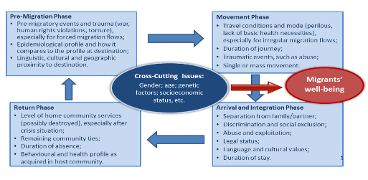
Human mobility, whether resulting from migration or international travel, can be a critical factor in the spread of disease and/or a challenge to controlling it. The Ebola crisis reminded us how a lack of targeted health services and surveillance along mobility pathways undermines effective disease control measures. Most national pandemic preparedness and response plans, however, do not address vulnerabilities and needs of mobile groups and foreign-born individuals.

Additionally, migration and health is also important from a Sustainable Development Goal perspective. It is now widely acknowledged that migration carries a development potential, owing to migrants’ intellectual, cultural, social and financial capital, and their participation in societies of origin and destination. Being and staying healthy is a fundamental precondition for migrants to work, be productive and contribute to the social and economic development of their communities, both of origin and destination.

Resetting the Agenda of Migrant Health
Acknowledging the inherent connection between migration and health, WHO Member States adopted the 2008 World Health Assembly (WHA) Resolution on the health of migrants (WHA.61.17). The Resolution paved the way for the 2010 Global Consultation on Migrant Health in Madrid, which was co-organized by IOM, WHO and the Government of Spain and defined an operational framework to guide Member States and stakeholders in implementing the strategies of Resolution WHA.61.17. This Operational Framework reaffirmed the need of adopting a rights-based, equity-driven, health system strengthening, multi-sectoral approach in addressing health and migration and identified four priority areas for action, namely: Monitoring of migrants’ health; Policy and legal frameworks; Migrant-sensitive health systems; and, Partnerships, networks and multi country frameworks.

Figure 2- Madrid Operational Framework: Priorities
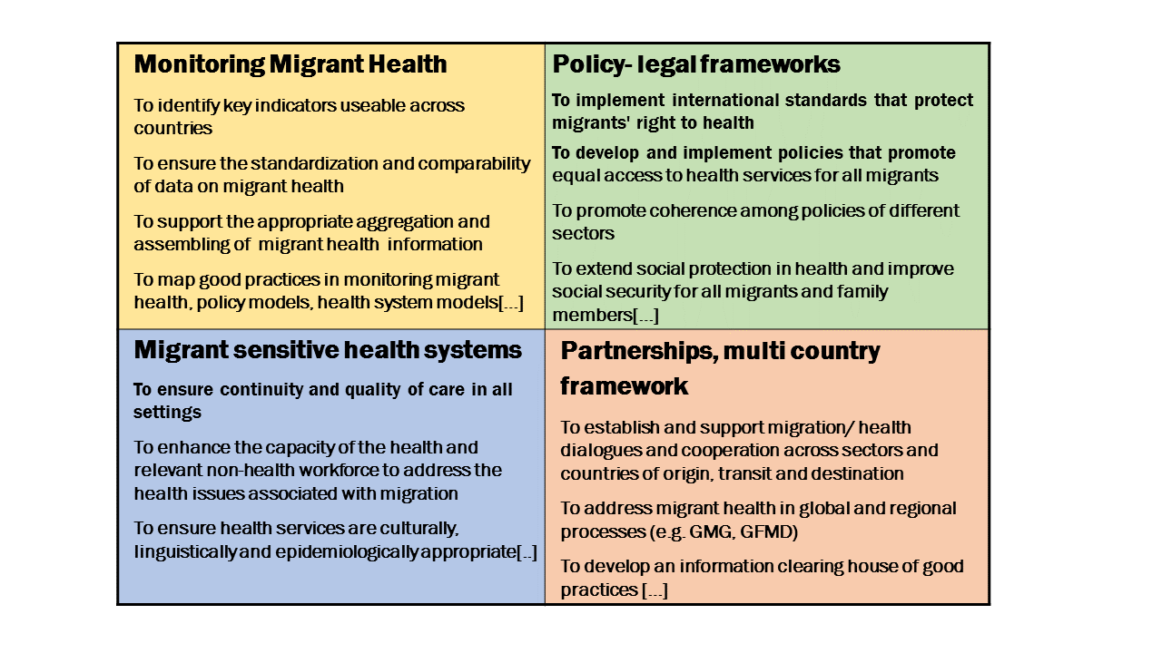
The Operational Framework was presented at the 63rd WHA and has since been used by a number of governments and health actors for policy and health strategy planning. Yet while awareness and recognition of the urgency to adapt policies and programmes, across sectors, to the health challenges brought by global human mobility is on the rise, the adaptation and development of necessary technical and policy instruments remains slow. Whether considering migrant health through the lens of forced displacement and human security, or humanitarian assistance, health security, inequity, or international development, policies across sectors are lagging behind and are often uncoordinated. Migrant health remains under-researched, scarcely addressed by many health systems and an absent theme in key international health dialogues, as well as in migration governance fora. Meanwhile, millions of migrants are still denied access to health services and remain invisible to global health initiatives, either in the context of large, acute crisis-driven migrant influx, or within the long-term, structural, economic and disparity-driven migration flows.

With migration being such a prominent factor in society today, governments are faced with the challenge of integrating the health needs of migrants into national plans, policies and strategies across sectors, responding to the call to ‘leave no one behind’, stated by the UN 2030 Agenda for Sustainable Development and the new Sustainable Development Goals. Coordinated efforts are needed to ensure that migrant health is addressed throughout the migration cycle, as are efforts to adapt and strengthen the resilience of local health systems in light of more diverse population health profiles. Addressing the health needs of migrants and affected local populations reduces long-term health and social costs, is a good public health practice, facilitates integration and contributes to social and economic development. The healthier migrants are and remain, the more efficient and balanced will be the future of our integrated and globalized world.

At the 106th IOM Council in November 2015, the urgency of advancing the unfinished agenda of migrant health was emphasized by IOM Members States through the organization of a High-level Panel on Migration, Human Mobility and Global Health. During the Session, IOM had the honor of being addressed by the President of the Democratic Socialist Republic of Sri Lanka, His Excellency Maithripala Sirisena. In his message, H.E. President Sirisena invited IOM to lead and Member States to participate in a Global Consultation on migrant health, to be hosted by Sri Lanka in 2016. A call to stepping up action on refugee and migrant health was also expressed by Member States of the WHO European Region during a High-level Meeting hosted by the Italian Government in Rome, also in November 2015, and discussed during the 138th session of the WHO Executive Board in January 2016.

In addition, during the 69th World Health Assembly in May 2016, a Technical Briefing session was dedicated to the topic of ‘Migration and Health’. WHO Member States also debated and took note of the Secretariat report on ‘Promoting the Health of Migrants’ (WHA A69/27). These milestones are a testimony of the fact that migration and health is a topic of interest for many governments today and requires a dedicated and in-depth discussion to redefine the global agenda, taking stock of current trends and perspectives.

- THE 2nd GLOBAL CONSULTATION ON MIGRANT HEALTH
In response to the renewed international attention to the topic, IOM, WHO and the Government of the Democratic Socialist Republic of Sri Lanka aim to jointly organize the 2nd Global Consultation on Migrant Health. IOM and WHO are committed to offering Member States and partners a meaningful and sustained platform for multi-sectoral dialogue and political commitment towards enhancing and mainstreaming the health of migrants.

Objectives
- To share lessons learned, good practices and research in addressing the health needs of migrants since the adoption of the 2008 WHA Resolution, the 2010 Global Consultation and the 69th WHA session, including WHA report (A69/27) ‘Promoting the health of migrants’ and the Technical Briefing on Migration and Health, and to identify gaps, opportunities and new challenges;
- To reach consensus on key policy strategies to reach a unified agenda across regions on the health of migrants, reconciling acute large scale displacement, as well as long-term economic and disparity-driven structural migration, and to pave the way towards a possible roadmap of key benchmarks;
- To engage multi-sectoral partners at policy level for a sustained international dialogue and an enabling policy environment for change.

Expected outcomes
To facilitate a continuation of the political dialogue on the advancement of migrant health:
- A common position paper, the “Colombo Statement”;
- A Report on the Consultation to be presented to the 107th IOM Council (December 2016) and the 140thSession of WHO Executive Board (January 2017);
- A renewed Migration Health Conceptual Framework for Member States for addressing Global Migration Health Challenges;
- An agreed upon ‘Accountability Framework’, based on the 2010 Madrid ‘Operational Framework’, including a set of indicators to also be considered within a possible new WHA Resolution on the health of migrants, within relevant SDGs, and in line with the priorities as outlined in WHA report (A69/27) ‘Promoting the health of migrants’;
- A common roadmap towards research and policy dialogue milestones 2016-2018;
- Elements for the establishment of an international network of expertise on migrant health and an information sharing platform.

Participants
An estimated 100 invited multi-sectoral participants, including representatives of Member States, partner agencies, civil society, private sector and academia.

Methodology
The Scientific Committee is the technical group that will assist the Organizers in the decision-making about the event’s scope, agenda, speakers, background materials to be produced and participants to be invited. The Committee will be comprised of experts from selected Member States, technical consultants, academia, civil society and International Organizations, and will also be called upon for peer review and validation of background documents and reports.

The Support Team, including colleagues of the Organizers in both IOM and WHO at Headquarters, Regional and Country Offices in Sri Lanka, will coordinate the organization of the Consultation including media outputs, invitations, hiring of consultants, editing of background documents, logistics and coordination.

Scope
Considering new trends and emerging debates on migration and health, the Consultation will take stock of views and experiences to “reset the global agenda of the health of migrants”. In particular, three thematic areas defining global agendas and paradigms are proposed, within a rights-based, people-centered, gender and equity approach:
- Global Health: to promote preventive and curative health approaches to reduce disease burden in migrants and host communities, calibrated along Universal Health Coverage, People-Centered and Integrated Health Services, Primary Health Care and Health System Strengthening concepts.
- Vulnerability & Resilience: to reduce vulnerability and enhance resilience of migrants, communities and systems, calibrated along the Social Determinant of Health model and Equity in Migrant Health concepts.
- Development: to ensure health of migrants is made an integral part of the 2030 Agenda for Sustainable Development, and key indicators to monitor progress of achievements are identified, calibrated along the Sustainable Development Goals.

Figure 3- Proposed Scope, three thematic areas

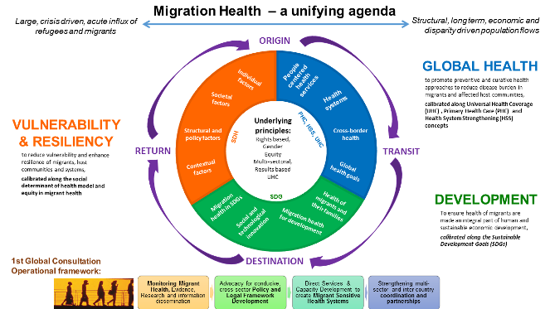

Proposed Format
This will be a 2½-3 day consultation, which will include:
- Keynote addresses by the Organizers;
- Plenary technical sessions that cover the rationale of the Consultation and the three proposed thematic areas;
- Three Working Group sessions along mentioned thematic areas where the focus will be on formulating recommendations for the Accountability Framework;
- High-level panel session (half day) to present and adopt the Colombo Statement;
- ‘Way forward’ session to finalize and operationalize the Colombo Statement and ways forward for involved sectors;
- Speakers will include government representatives, technical experts from international organizations, academia, policy makers and civil society from various relevant sectors;
- Pending resources: Market place research symposium (half day) for the presentation of posters and key research outcomes in the domain of migration health.

The working language of the event will be English.

Preliminary list of background materials
- Three Background papers on the proposed thematic areas
- The 2010 Global Consultation on Migration Health in Madrid report
- 2008 61st WHA Resolution
- 2015 138th WHO EB Secretariat document
- 2015 106th IOM Council document
- 2016 69th WHA report (A69/27) ‘Promoting the Health of Migrants’, and the report on the outcomes of the Technical Briefing on Migration and Health

Budget items
- Coordination of staff at IOM and WHO Offices at HQ and Sri Lanka
- Consultants to prepare background papers and final report
- Travel and accommodations for selected participants
- Management of information portal
- Venue, refreshments and security protocol
- Printing of report

Estimated budget: USD 320,000 (excluding venue, provided in-kind by the Government of the Democratic Socialist Republic of Sri Lanka).

There is no official definition of the term migrant adopted by all UN agencies or related International Organizations. IOM defines a migrant as any person who is moving or has moved across an international border or within a State away from his/her habitual place of residence, regardless of (1) the person’s legal status; (2) whether the movement is voluntary or involuntary; (3) what the causes for the movement are; or (4) what the length of the stay is.

