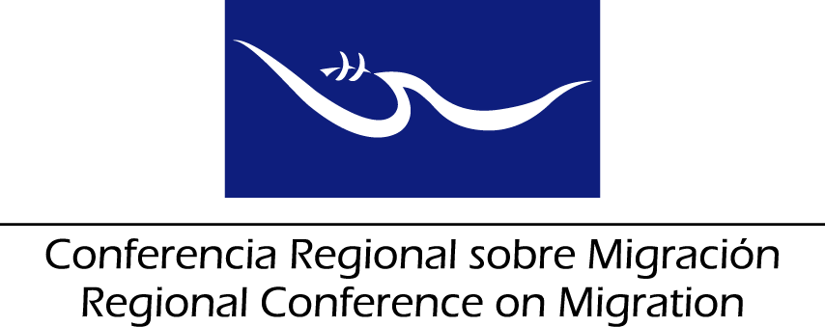
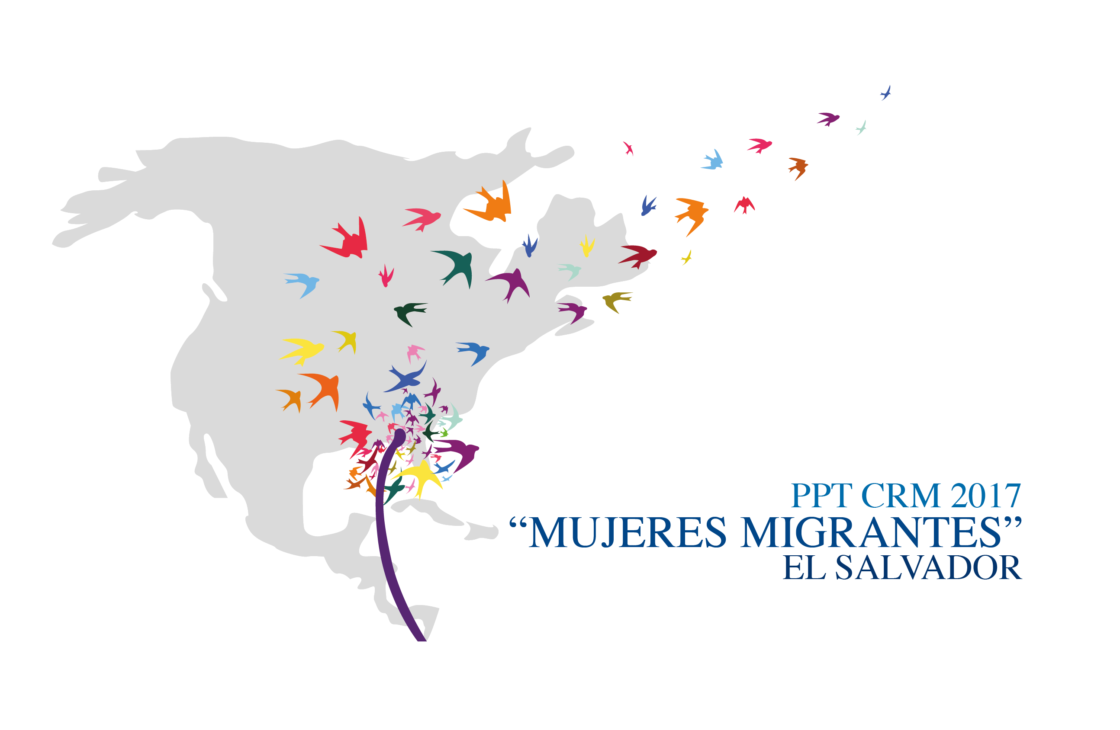

Child’s Best Interest and Sexual Gender-Based Violence case management in migration and refugee contexts”
“Protecting Girls in the RCM Member Countries”

Following up on the First Meeting of the Regional Conference on Migration (RCM) Liaison Network for Protecting Migrant Children and Adolescents, held on 16-17 March in Tegucigalpa, Honduras, the conclusions of which, in Item 7, agreed to: “Receive with approval the UNHCR’s offer of support to conduct a training workshop for Network representatives on the day preceding the next RCGM Meeting, focused specifically on how to determine the best interests of the child when handling cases involving sexual and gender violence against underage female migrants in need of international protection.”

Background
The new dynamics of human mobility in the region placed children and adolescents at serious protection risks faced by children and adolescents in their countries of origin, while in transit, and upon arrival at their destination (mainly Mexico and the United States, but also other countries such as Guatemala, Panama, Costa Rica, and Belize). At the same time, specific protection risks for girls and young women have been detected with greater frequency in recent years for those involved in these migratory flows.

Particularly women and girls face sexual and gender-based violence (SGBV) in both private and public spheres during the migratory route from the place of origin to the place of destination. This poses a threat to their integrity, within their national borders as well as in other countries. There are reports indicating that in some countries violence against individuals with diverse sexual orientation and/or gender identity increased in 2016. Being part of a minority ethnic group, or a person with disabilities placed them at additional risk of violence and exploitation.

As a response, with support from civil society and the observer agencies, the Regional Conference on Migration established the Ad Hoc Group on Migrant and Refugee Children and Adolescents in June 2014. Meanwhile, the State members to the Southern Common Market (MercoSur) requested to the Inter-American Court for Human Rights an Advisory Opinion regarding migrant children and/or migrants with special international protection needs. The Advisory Opinion 21/14 dated 19 August 2014 defined the rights and guarantees of children in the context of migration and/or in need of international protection.

At Mercosur level, a Regional Guide for Identifying and Addressing the Special Protection Needs Related to the Rights of Migrant Children and Adolescents was initiated, while the Ad Hoc Group on Migrant and Refugee Children and Adolescents (RMC) developed the following instruments to respond to the protection needs of this vulnerable group:
- Regional Action Guidelines for the Comprehensive Protection of Children and Adolescents in the Context of Migration.
- Consular Protection Recommendations for Migrant Children and Adolescents, Including Unaccompanied or Separated Persons in Need of International Protection.
- Common Indicators for Recording Unaccompanied or Separated Migrant Children and Adolescents as part of Consular Actions by the Member Countries of the Regional Conference on Migration.

In light of the circumstances described, the Vice-Ministers attending the XXI RCM Meeting resolved to:
- Approve the guidelines, recommendations, and indicators prepared by the Ad Hoc Group.
- Establish the Liaison Network for Protecting Migrant Children and Adolescents (hereinafter referred to as the ‘Child Protection Network’).
- Approve the ‘Migrant Women’ theme for the RCM in 2017, as proposed by El Salvador, this year’s RCM Pro-Tempore President.

In spite of these achievements, the Ad Hoc Group on Migrant and Refugee Children and Adolescents and other bodies of the RMC have pointed out in several meetings the need to continue building the capacity and knowledge of relevant actors in the region to ensure access of migrant and refugee girls to specialized services for child survivors of SGBV, including safe and confidential child’s best interests procedures and case management.

In this context, UNHCR would like to contribute to the development of specific skills for responding to such needs by supporting the organization and facilitation of a day-and-a-half workshop to the relevant personnel of the State Members to the RCM.

Along these lines, during the first meeting of the Liaison Network for Protecting Migrant Children and Adolescents, held on 16-17 March in Tegucigalpa, Honduras, it was agreed to:
“Receive with approval the UNHCR’s offer of support to conduct a training workshop for Network representatives on the day preceding the next RCGM Meeting, focused specifically on how to determine the best interests of the child when handling cases involving sexual and gender violence against underage female migrants in need of international protection.
It is important that invitations be issued to Member Country agencies involved in protecting women.”

The general objective of this workshop is to strengthen the technical skills and capacity of child protection and women protection personnel, and migration and asylum officials, on the implementation of Child Best Interests Determination Procedures and Sexual and Gender-based Violence (SGBV) case management. The workshop will provide, to staff who work directly with migrant children and/or refugees, knowledge and practical skills on global and regional tools to address the protection needs of migrant and refugee girl survivors of SGBV, including the UNHCR Guidelines for Determining the Best Interests of the Child and the respective Manual, or the Inter-Agency Guidelines on SGBV case management.

Training Objectives

Upon conclusion of the Training Workshop, the participants will be able to:

- Access the most updated related research, tools, and policies for protecting child survivors of SGBV in a practical and relevant manner, within the working contexts of the region’s officials.

- Analyse each situation and the available information in order to identify the protection needs of children and adolescents and the proper priorities and responses, in accordance with the best interests of the child and the survivor centred approach.

- Promote the establishment of multi-sectoral Best Interests Determination Panels in the different working contexts in the region.

Participants

Child protection and women protection personnel, and migration and asylum officials who work directly with or directly supervise the work with migrant and refugee children and adolescents in the RCM State Members.

State Members are kindly requested to propose a maximum of three participants each. The name, title, institution, and contact information for each proposed participant should be sent by e-mail to the RCM Technical Secretariat no later than May 29th.

Place and Dates

The Training Workshop will be held on 19-20 June 2017, prior to the RCM Liaison Networks Meeting, at the facilities of the Ministry of Foreign Affairs of El Salvador.

For more information, please contact Ana Irma Rodas de Mendoza at airodas@rree.gob.sv, the RCM Technical Secretariat at CRMST@iom.int, and/or the Regional Legal Unit (Child Protection and SGBV) at cossarlu@unhcr.org.

UNHCR Eligibility Guidelines for Assessing the International Protection Needs of Asylum-Seekers from Honduras. UN High Commissioner for Refugees (UNHCR), 27 July 2016; HCR/EG/HND/16/03. Available at: http://www.refworld.org/docid/579767434.htm (EN); www.acnur.org/fileadmin/Documentos/BDL/2017/11033.pdf (SP)
Women on the Run: First-Hand Accounts of Refugees Fleeing El Salvador, Guatemala, Honduras, and Mexico. UNHCR, 2015.
Comprised of representatives from the Foreign Affairs Ministries, Migration Directorates, and Child Welfare Agencies of all Member Countries. In addition, the IOM, UNHCR, UNICEF, CICR, and the Regional Network of Civil Organizations for Migration (RROCM) participated as observers.
Previously titled Regional Guidelines for the Comprehensive Protection of Boys, Girls, and Adolescents in the Context of Migration.

