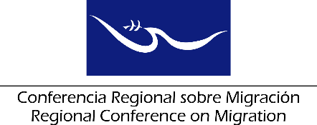
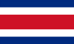

Regional Conference on Migration (RCM)
II Migration Health Workshop

Concept Paper

The Regional Conference on Migration (RCM) recognizes the critical importance of healthy communities and individuals across the migration continuum, from pre-departure through to settlement in destination communities. Two prior events on Migration Health have been held by the RCM, in 2004 and 2016, and Migration Health has now been included as a standing item in the agendas of the Regional Consultation Group on Migration (RCGM).

The first RCM Seminar on Migration and Health in Guatemala City in October 2004 was co-sponsored by Canada and Mexico. A wide range of issues were covered, including the latest information from all participating governments and international organizations, such as lessons learned from the response to Severe Acute Respiratory Syndrome (SARS) that had recently affected countries across the globe.

In the wake of the Ebola crisis and the regional spread of the Zika virus in the Americas, the 2016 Migration Health Workshop co-sponsored by Costa Rica and with the support of IOM and PAHO, succeeded in bringing together migration and public health officials from RCM member states and international organizations. The event provided an opportunity for the exchange of new findings, policy innovations and important lessons from across the region. The 2016 workshop provided valuable first-hand sharing of experiences, expertise, and best practices from a wide range of contexts, and established important lines of communication. Despite the wealth of information shared at the event, migration movements and health issues of relevance to RCM countries and international organizations continue to evolve. Among the Conclusions and Findings of the workshop, participants noted the importance of having a follow-up conference within two years.

The World Health Assembly agreed during 2017 on the need for strengthening partnerships, intersectoral, intercountry and interagency coordination and collaboration towards improving the health of refugees and migrants; concurrently, the United Nations Global Compacts on Migration and on Refugees are aiming to finalize their work in 2018 and the WHO International Health Regulations will be updated. In this context, the RCM can leverage, as a regional forum, the goals of these overarching initiatives and pursue more specific information exchanges aligned with their goals.

Canada proposes that the RCM fulfill the advice from the 2016 event, and asks for the RCM to approve a two-day workshop to be held in late 2018 or early 2019, where policy and program specialists from government agencies, civil society and international organizations focused on migration health will continue to exchange information on policies, programs, best practices and lessons learned.

The two-day event could potentially include the following agenda items:

- Outbreak response – experiences and lessons learned
- International Health Regulations and migration programs
- Tuberculosis – WHO/PAHO strategies, health screening and target populations
- The mental health impact of economic and social dislocation
- Health services for migrants and refugees
- Migrant outreach and public awareness
- Bridging the divide between migration and health areas in government and society
- Networking, partnerships and information development
- Identifying future goals and challenges for migration health initiatives in RCM countries

Canada would welcome co-sponsorship with another country, particularly for hosting the event in a central location that facilitates participation by all member countries, as well as the support and participation by other member countries and international organizations.

