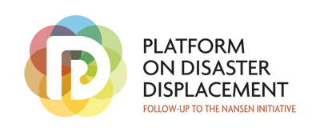 | 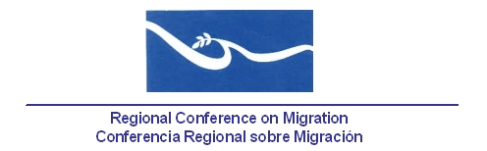 | 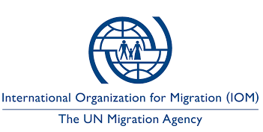

Regional Conference on Migration -RCM-
International Organization for Migration -IOM-
Platform on Disaster Displacement -PDD-

Capacity Building/Training Workshop on Disaster Displacement, Migration and Climate Change for RCM member countries

San José, Costa Rica, 8-9 August 2017

I. Introduction
Forced displacement related to disasters and natural hazards, including the adverse effects of climate change (disasters displacement), is a reality and one of the major humanitarian challenges facing States and the international community today.
Members countries of the Regional Conference on Migration (RCM) are exposed to a wide range of natural hazards, including floods, hurricanes, droughts, tsunamis, earthquakes, volcanoes, fires and landslides, each of them has the potential to induce population movements. Following disasters caused by these natural hazards, displacement and migration have occurred within member countries of the Regional Conference on Migration (RCM), to and from these countries and other States, in the Americas and outside the region.
Although the RCM had previously analyzed the consequences of disasters and their impact on migration, it was not until the XIX Regional Conference on Migration held in Managua, Nicaragua in 2014, when the Vice Ministers from the area agreed to celebrate a regional workshop on temporary protection and humanitarian visas in disaster situations.
This workshop took place in San José, Costa Rica in February 2015 and as a result, it was agreed to work on a non-binding regional document incorporating best practices used by RCM member countries. The draft of this document was discussed, circulated and improved with the support of the countries of the region for more than two years and was finally approved during the XXI Vice-Ministerial Meeting of the Regional Conference on Migration in San Pedro Sula, Honduras in November 2016, in which the Vice Ministers of Foreign Affairs and Government welcomed the document and urged the RCM member countries to implement it, as well as holding regional training workshops on this thematic in 2017.

The adoption of this document (‘Protection for people moving across borders in the context of disasters. A Guide to Effective Practices for RCM Member Countries’) is a milestone in the context of the RCM, in relation to non-binding guiding practices on disaster displacement, which contain humanitarian provisions in two basic scenarios: (I) Humanitarian protection for foreigner from countries affected by disasters; and (II) Protection for migrants living or in transit in a country affected by a disaster.

II. Background: Platform on Disaster Displacement –PDD- and the Migration, Environment and Climate Chance Division of the International Organization for Migration (IOM)

This workshop was designed jointly and thanks to the collaboration of the Technical Secretariat of the Regional Conference on Migration (RCM), Platform on Disaster Displacement (PDD), the Regional Office for Central America, North America and the Caribbean of the International Organization for Migration (IOM) and the Environment, Climate Change and Migration Division (MECC) of the same organization based in Geneva, Switzerland.
The Platform on Disaster Displacement -PDD- has been established to follow up on the work initiated by the Nansen Initiative and to implement the recommendations of the ‘Protection Agenda’, a non-binding document endorsed by 109 countries at an Intergovernmental Consultation that took place in October of 2015 in Geneva. It contains a set of basic principles and effective practices on the protection needs of these people and practical tools on how best to address them. The overall objective of the Platform is to strengthen the protection of displaced persons across borders in the context of disasters, including those related to the effects of climate change, and to prevent or reduce the risks of disaster displacement.
On the other hand, thanks to the work of the IOM’s Division of Migration, Environment and Climate Change (MECC), States and other stakeholders have the opportunity to be trained and use the ‘Training Manuals on Migration, Environment and Climate Change', which contains a series of modules which provide in-depth insight into the links between migration, environment, mobility, disasters and slow-moving events, as well as data, legal issues and regional perspectives on integrating human mobility into public policies, including climate change adaptation policies.

III. Objectives

This regional training workshop on displacement in the context of disasters, migration and climate change (designed for RCM member countries) seeks to:

'Contribute to the strengthening of national technical capacities for RCM member countries, in relation to migration and consular management and humanitarian response for the protection of displaced persons in the context of disasters of natural origin'

Specific objectives:

- To discuss the linkages between human mobility and climate change, including the different forms human mobility adopts related to natural disasters.

- Analyze existing international and regional legal frameworks for the protection of disaster-induced cross-border displaced persons, as well as the protection needs of disaster-affected migrants.

- Discuss the content, general provisions and principles of the document 'A Guide to Effective Practices for RCM Member Countries. Protection for persons moving across borders in the context of disasters'.

- Identify institutional and normative opportunities and gaps for the implementation of the Guide by the RCM member countries.

IV. Participant profile
The number of participants has been estimated at a maximum of 35 approximately, including government representatives from the 11 member countries of RCM with technical and/or political decision-making with expertise/responsibilities related to:
- Ministries of Foreign Affairs (Consular Departments).
- National Immigration Authorities or Immigration Directorates.
- Officials responsible of climate change adaption and/or disaster risk management (whose work is especially liked to human mobility).
The list of participants could include the participation of a few observers and representatives of international and regional organizations.
V. Practical and Logistic issues
The event will be held under the auspices of the Government of Costa Rica as the host country and it will be coordinated jointly by Platform on Disaster Displacement (PDD), the Technical Secretariat of RCM (TS-CRM) and the International Organization for Migrations -OIM-. The workshop's co-organizer team will be in charge of all technical and logistical aspects of the event and will have the support of the Technical Secretariat of the Regional Conference on Migration (TS-RCM) for the purchase of air tickets, accommodation and other logistics related to the workshop.

VII. Contact

RCM Technical Secretariat
Regional Conference on Migration -RCM-
Tel: (+506) 2212-5327
Fax: (+506) 2222-0590
Email: CRMST@iom.int
www.crmsv.org / www.rcmvs.org

Platform on Disaster Displacement PDD.
Juan C. Méndez | Regional Advisor. Platform on Disaster Displacement | Follow-up to the Nansen Initiative. San José, Costa Rica |
Email: juan.mendez@disasterdisplacement.org | jcmendez@cne.go.cr
Tel +506 2210 2841 | +506 8317 6336

Between 2008 and 2014, a total of 184.4 million people were forced to move in the context of sudden disasters, that is, an annual average of 26.4 million new displaced persons, of which an average of 22.5 million of people were displaced by threats related to meteorological events each year. See: Internal Displacement Monitoring Center (IDMC), Global Estimates 2015: People displaced by disasters. Geneva: IDMC, p.8.
The joint communiqué of the IV Regional Conference on Migration addresses the impacts of Hurricane Mitch in 1998. The member countries "... agreed that the Conference [RCM] is an ideal forum to address the migratory aspects derived from this natural disaster through the application of an comprehensive vision raised by the Puebla Process, with emphasis on the link between migration and development. "[highlight is not from the original].
Regional Conference on Migration (2016). Declaration of the XXI Regional Conference on Migration (CRM) “Migration: a shared responsibility. San Pedro Sula, Honduras.

