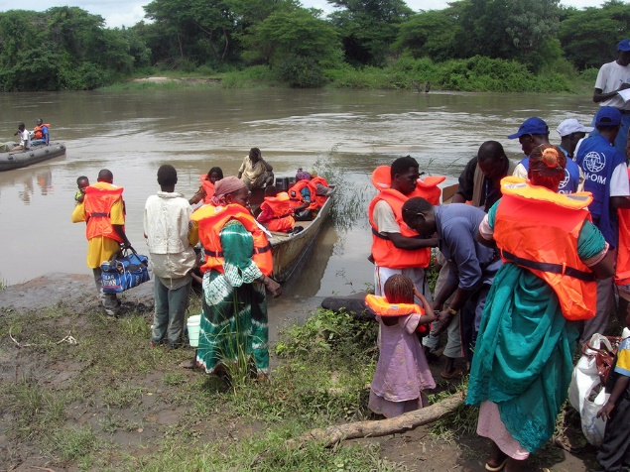
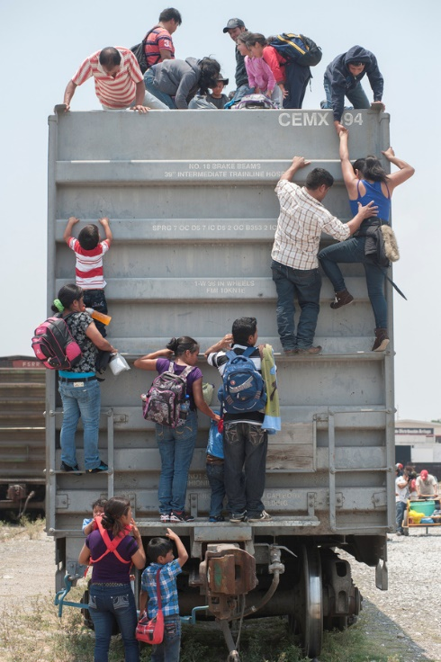
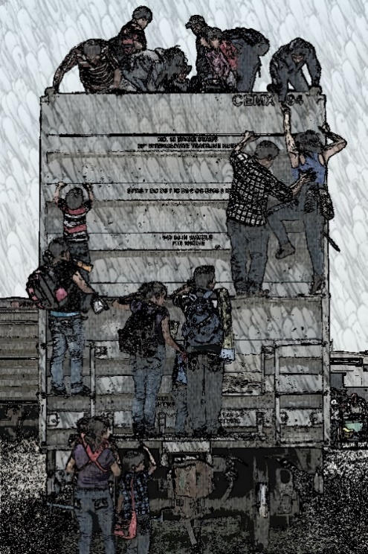
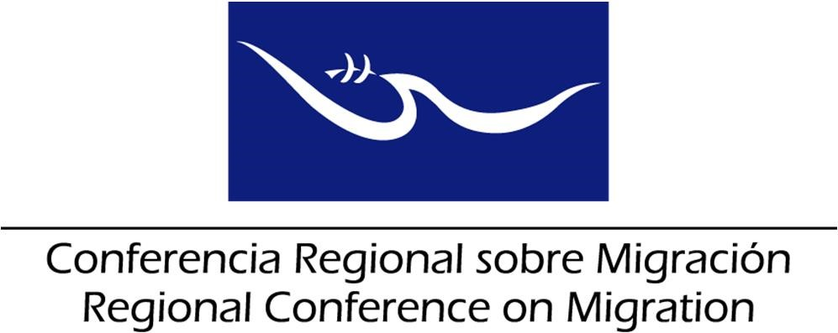

Proposal Plan of the Ad Hoc Working Group on Extra-Regional Migrants

Document prepared by the Technical Secretariat, based on the results of the IV Meeting of the Ad Hoc Working Group (July 6-7, 2017)
I Semester, 2018

AXIS: INFORMATION
Objectives | Activities | Responsible | Calendar
Promote information campaigns to discourage irregular extra-regional migration. | Implement and disseminate the information campaigns on risks and dangers of irregular migration, adopted within the framework of the RCM. (Examples: "Blue Heart" and “Migrant Smuggling: #DeadlyBusiness”).  Request the Focal Points to publicize the products of the information campaign. | Member Countries | Continuous
Implement the tables proposed by Mexico for the collection of information on extra-regional migrant flows. | Complete and send in time the charts for the collection of information on extra-regional migrant flows. | Member Countries, TS and Mexico | Every six months
Create, from the first countries of entry and on the route, clear information tools on the possibilities of asylum and other refuge mechanisms accessible to these migrants and in force in the legislations of the various Member Countries. | Share information about the possibilities of asylum and other refuge mechanisms.  Identify other alternative measures, to safeguard the principle of non-refoulement. | Member Countries | Continuous
Develop an early warning system. | Maintain on the private site of the virtual secretary of the RCM, a database with input from Member Countries on false documents and travel documents obtained fraudulently. | Member Countries and TS | TBD
AXIS: COORDINATION

Objectives | Activities | Responsible | Calendar
Assist in the continuity of joint operations to combat migrant smuggling gangs. | Exchange intelligence information on immigration control.  Regularly exchange information on specimens of travel and / or migratory documents.  Regularly exchange police intelligence information on procedures and methods for fraudulently obtaining travel documents. | Member Countries | Permanent
Elaborate guidelines for the care in shelters and management of migratory crises. | Take as a baseline the manual that IOM jointly developed with Panama. | Panama and IOM | TBD
Monitor the trends and behavior of extra-regional flows and the identification of migration routes. | Exchange intelligence information on immigration control. | Member Countries | Permanent
Implement the "Plan to strengthen the governance of extra-regional migrant flows in Mesoamerica," presented by IOM in September and October 2016. | Disseminate the Plan within the countries. | Member Countries | Permanent
Implement the "Regional guidelines for the preliminary identification of profiles and reference mechanisms of migrant populations in vulnerable conditions" approved in 2012 by the RCM and adapt them to the reality of extra-regional migrants. | Disseminate the Plan within the countries. | Member Countries | Permanent
AXIS: COOPERATION

Objectives | Activities | Responsible | Calendar
Establish a network of consulates in Washington that includes RCM countries and countries of origin to address extra-regional flows. | Request the focal points of the consulates in Washington, for the establishment of the network.  Inform and update the Consular Directorates of the Member Countries of the RCM on the progress of these efforts.  Strengthen diplomatic communication with the representation of Haiti. | Liaison Officer Network for Consular Protection | II Semester 2018
Implement continuous training processes on refuge and asylum for personnel who have direct contact with the extra-regional migrants. | Request support from UNHCR to implement training modules. | Member Countries  UNHCR | Yearly
Request IOM to update the matrix on legislation against migrant smuggling and the information on the compliance with the Palermo Protocol. | Follow up in the framework of the Liaison Officer Network to Combat Migrant Smuggling and Trafficking in Persons | Liaison Officer Network to Combat Migrant Smuggling and Trafficking in Persons  IOM | Every six months
Maintain contact and exchange of information with the SACM for the analysis of extra-regional flows and establish a bi-regional positioning on the subject. | Hold a RCM-SACM Plenary Meeting | Member Countries  RCM Troika | I Semester 2018
Work jointly with civil society organizations so that they can sensitize migrants about the risks and difficulties they may face during their journey to the countries of destination. | Involve civil society in the implementation of information campaigns on the risks of irregular migration. | Member Countries  RNCOM-RCM-TS Tripartite Team | Yearly

